CPS Project Report

**Greenhouse Monitoring System**

This project aims to monitor the Temperature and Humidity of the Greenhouse. The project aims to use Wi-Fi chip ESP 8266 to create the dashboard with Adafruit since we do not have MKR1000. In this project, we utilized humidity and temperature sensors connected using the Arduino controller to produce feed, upload to Cloud, and create the dashboard using the block settings. With this dashboard, one can monitor live temperature and humidity reading using the different sensors at different time intervals. A line chart uses to represent trends in temperature and humidity changes to visualize the data further. What’s more, we also installed two actors to the monitoring system: a DC motor-driven fan and a water pump. The fan attempts to cool down the greenhouse temperature, and the water pump attempts to increase the humility. In the below content, we are to illustrate the detailed design of this project.

# Cover Image:

# Skill Level:

The project aims at the advanced level of knowledge on the practice of Arduino Microcontroller, as it has two main components including the hardware and a solid understanding on how to effectively upload and publish sensor data to the MQTT server which is Adafruit Cloud Server in this project. Also, to successfully install the DC motor, it requires a good knowledge of using an H-Bridge to enable the microcontroller control on the motor. Meanwhile, a good understanding of how the stepper motor operates is a good aid to install the water pump in this project.

Tags:

#IoT, #Arduino, # Cyber physic system, # Greenhouse, # User-friendly

# Contributors:

Tong (Andrew) Lu 400071738

Luke Meng 400076302-Design

Masoodhur Rahaman 400346797

# Link

The link for the project: https://github.com/rahamm2/CPS-project, and the code is published there.

# BOM (Bill of Materials)

* Wi-Fi chip ESP 8266- $35
* Arduino controller-$27.98
* Micro USB cable for connecting the microcontroller to your computer-$9.99
* Few breadboards
* A humidity sensor
* A temperature sensor
* A fan with DC motor
* A water pump (we used a step motor since we haven’t received the pump yet)

The cost of the rest of the product is $59.95.

# Tools

* Extra-long, spring lever needle nose pliers
* Regular needle nose pliers
* Slip-joint pliers
* Tonge and groove arc-joint (aka Channel-lock) pliers
* Locking (Vice-Grip) pliers
* Wire cutters/strippers - though most modern pliers tend to have a wire cutter near the joint.
* Metal file
* Tape Measure

# Schematic

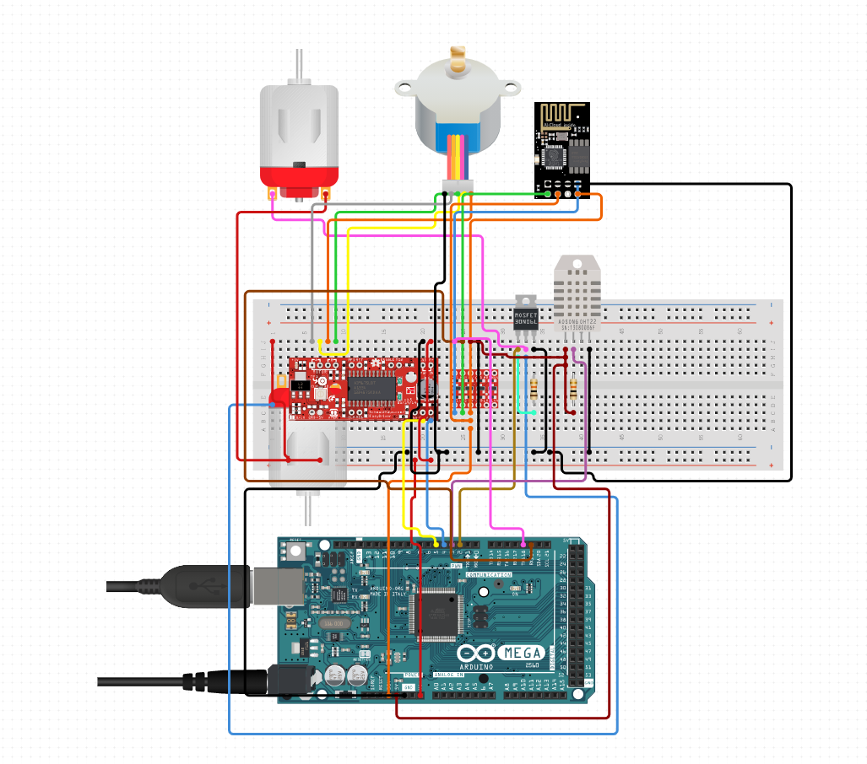

Figure 1

# Software

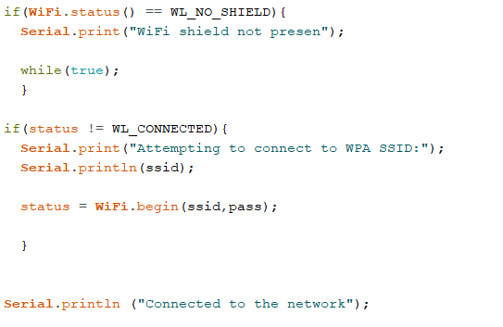

* Setting up the wireless internet connection through WIFI

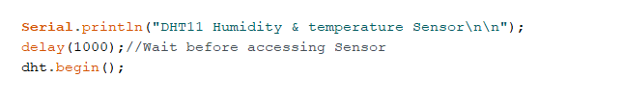

Enable the DHT Sensor

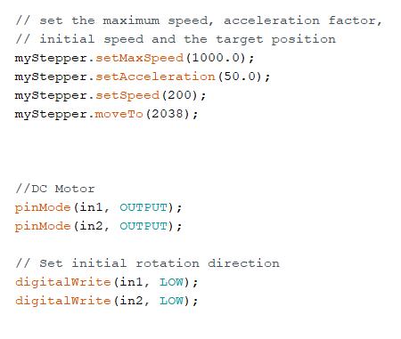

* Initial Parameters for the DC motor (Fan) and the Stepper Motor (Water Pump)

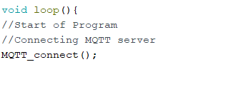

* Start Loop of the program – Connecting to the MQTT Server: Adafruit

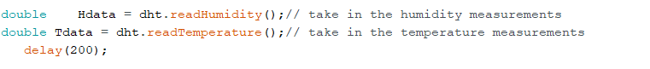

* Initial Scanning of the temperature and humidity data

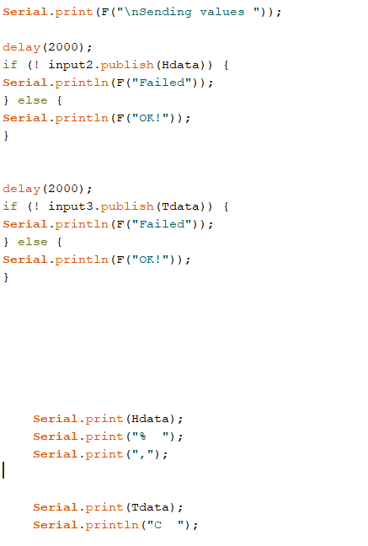

* Publishing data

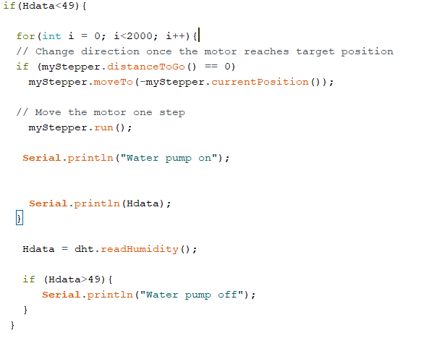

* Engage Water Pump if humidity is <49%

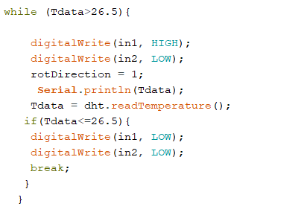

* Engage fan if overheating

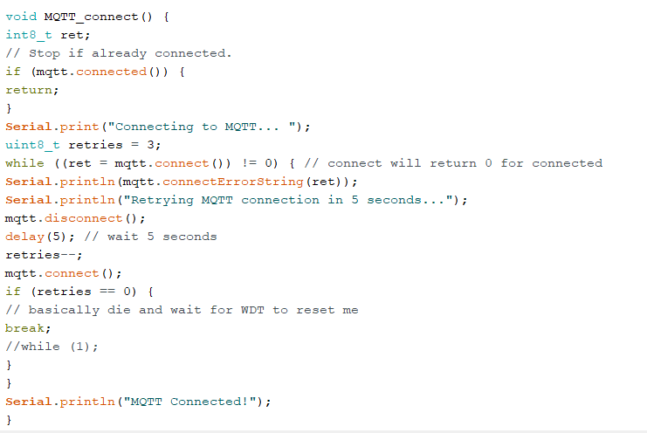

MQTT Connection

# Algorithm

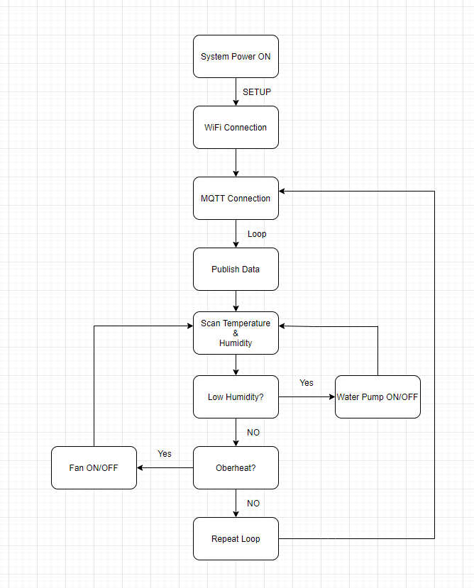

# Video

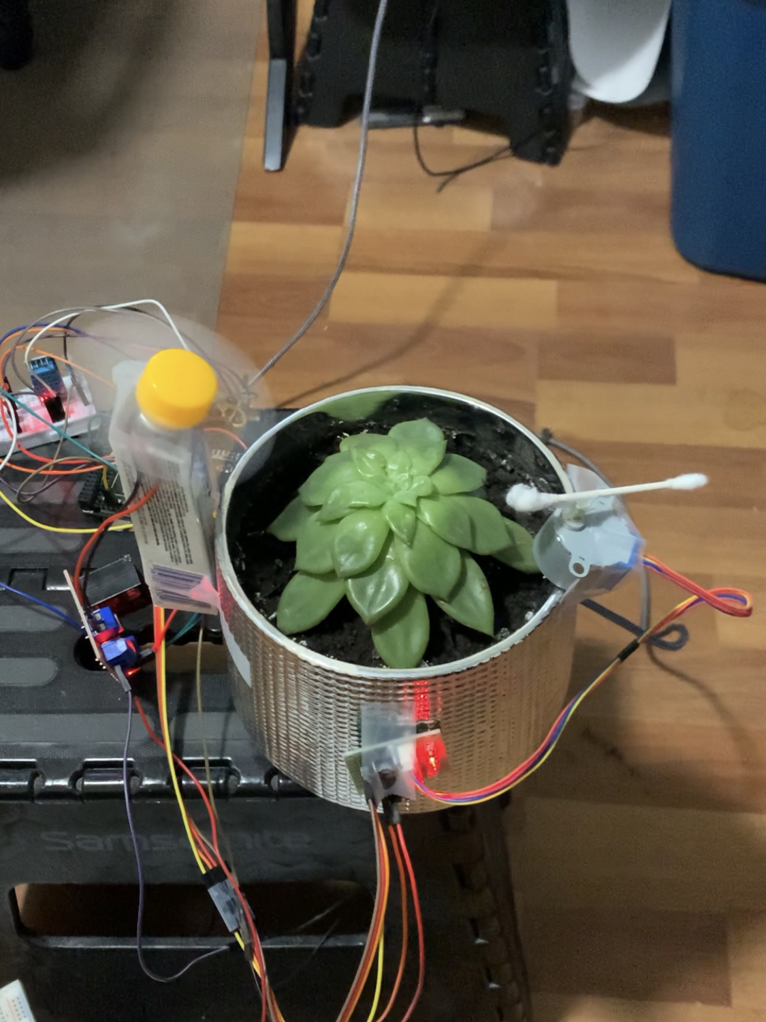

Figure 2

https://youtu.be/st4B9snLnrE

# Project Links

The project is published at GitHub. Please see the link for the GitHub repository:

<https://github.com/rahamm2/CPS-project>

Conclusion

In this project, we implemented a greenhouse monitoring system. The system will monitor the temperature and humidity of the greenhouse and adjust the greenhouse environment by the fan and the water pump. This cyber physic system integrates with the Wi-Fi chip, which the system can send real-time information to the Cloud, and the staff can monitor the greenhouse remotely. Furthermore, all the monitor information stored on Cloud and formed to be analyzed. Eventually, We hope this project can enhance green house’s efficiency and improve the quality of the plant growing. We will use a regression ML algorithm to predict the best greenhouse's temperature and humidity as the second part of this project.

# References:

Please share the links to online Tutorials and documentation you found helpful in doing this project.

## Arduino Project Hub:

<https://create.arduino.cc/projecthub?category=internet-of-things-bt-wireless&sort=trending>

## Getting started with the Arduino IoT Cloud:

<https://www.arduino.cc/en/Tutorial/iot-cloud-getting-started>

# Appendix:

